**Selenium Hands-on:**

**Day4 Tasks:**

**Debug the program:**

QUESTION 9

-----------

URL : http://www.gmail.com

NOTE: Login the gmail using debug steps.

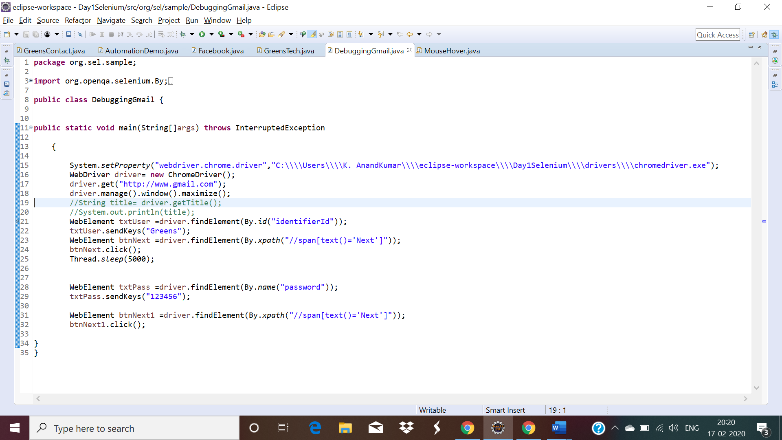

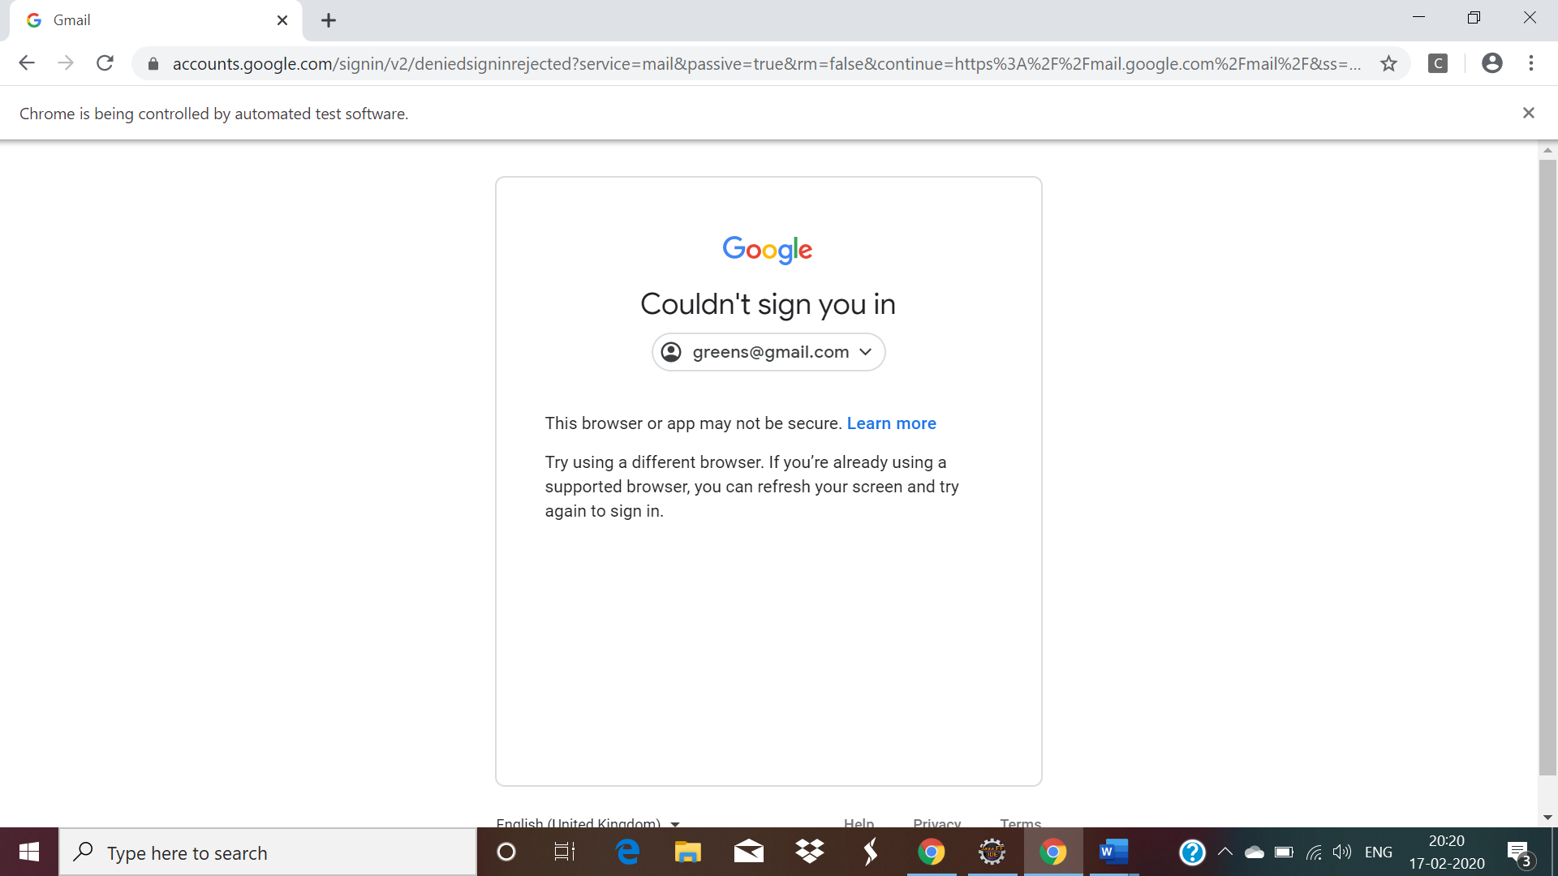

**Day4 Task:**

QUESTION 1

URL : https://www.facebook.com/

NOTE: Print the email and password you are given.

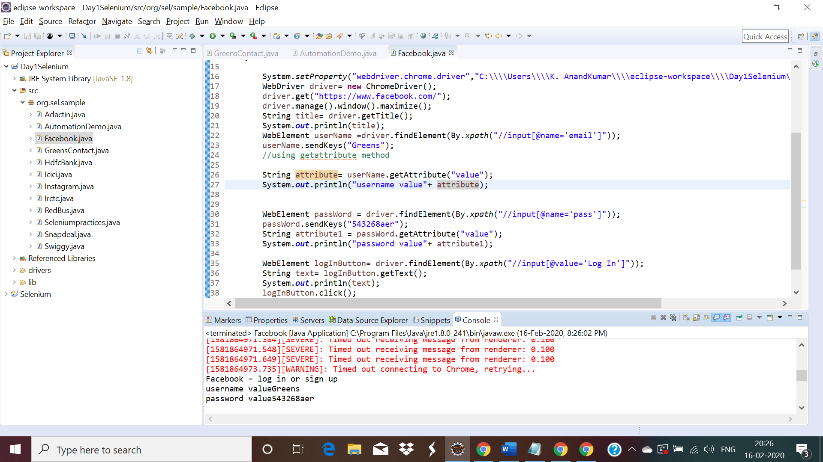

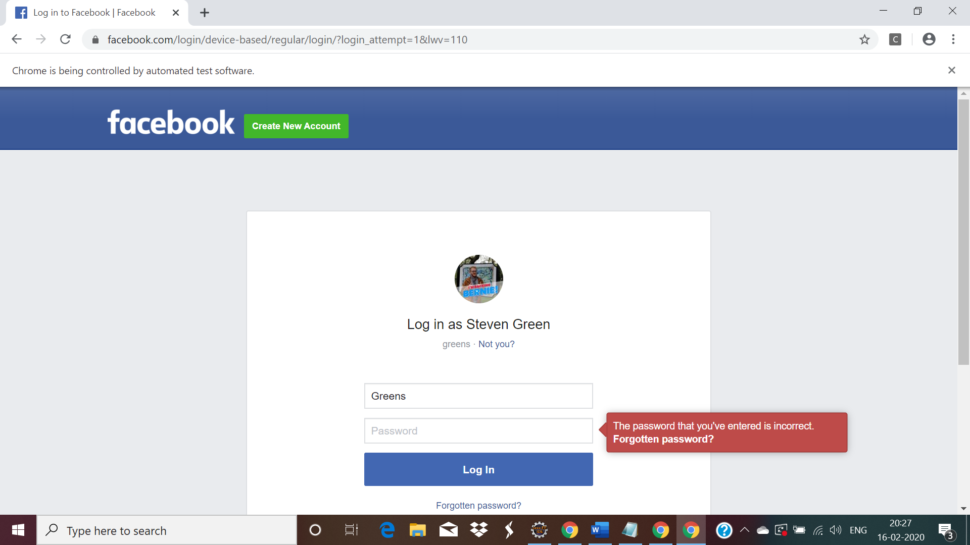

QUESTION 10

------------

URL : http://www.adactin.com/HotelApp/

NOTE: Print the UserName and Password that you are entered.

